|  |
| --- |
| **Objectives:**   * Solve geometry questions. * Solve trigonometry questions.   ***MONDAY (10.28.24****)* |
| **Entry Work:**   1. 30o = ____________ radians 2. 72o = ____________ radians 3. π/4 = ____________ degrees 4. 3π/5 = ___________ degrees   **Discuss the previously assigned homework:**  1)**Find the missing sides and angles. right triangle**  2)**Find the missing sides and angles. right triangle**  3)**Find the missing sides and angles. right triangle**  4)**Express**cos 32∘**in terms of sine.**  5)**Express**sin 48∘**in terms of cosine.**  (6) The base of a ladder is placed 3 feet away from a 10 -foot-high wall, so that the top of the ladder meets the top of the wall. What is the measure of the angle formed by the ladder and the ground?  A diagram of a rectangular object  Description automatically generated  **Class Work: Learn about/review The Law of Sines**  **The Law of Sines** (or**Sine Rule**) and **The Law of Cosines** are both very useful for solving triangles:  Law of Sines |  The Law of Sines works for any triangle, both right triangles and oblique triangles, when you know AAS, ASA, or SSA (Ambiguous Case).  **Class Work/Homework:** |

1. **ASA are given:** In ΔABC, C = 80º, B = 34º and a = 16.  
   Find side b to nearest whole number.
2. **AAS are given:** In ΔRST, R = 30º, T = 95º and r = 8.  
   Find s to nearest tenth.
3. **SSA** **are given**: In ΔABC, A = 30º, a = 7, and b = 16.  
   Find B to the nearest whole number.
4. **SSA are given:** In ΔABC, A = 30º, a = 20, and c = 16.  
   Find B to the nearest whole number.

Study for the Quiz (The Law of Sines) to be taken during your next class period.

***WEDNESDAY (10.30.24****)*

**Quiz: The Law of Sines**

**Class Work/Homework: Learn about/review The Law of Cosines.**

The Law of Cosines works for any triangle, both right triangles and oblique triangles, when you know SAS or SSS. The **Law of Cosines** (also called the **Cosine Rule**) says:

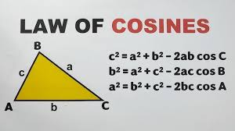

1. **SAS are given**: How long is side c, rounded to the nearest hundredth?

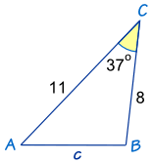

1. **SSS are given:** What is Angle C, rounded to the nearest tenth?

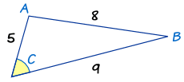

***FRIDAY (11.1.24****)*

**Discuss the previously assigned work.**

**Class Work: You will be given 2 problems to solve. Turn in for a Quiz Grade today or at the beginning of class on Wednesday, November 6.** Illustrate the situation. Use The Law of Cosines. Show all the work.